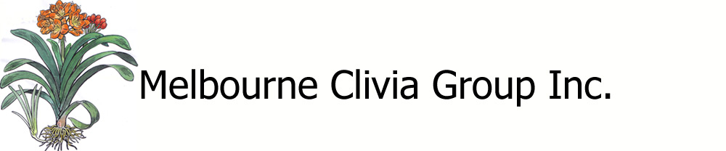

TRADING TABLE – APPLICATION TO SELL ITEMS

Name: _________________________________ Telephone: ____________________________
E-mail: ______________________________________________________
Number of items to be sold | Type of sale item (seed, plant, seedling, pollen, other) | Description (include botanical name, breeding or any other relevant information) | Price each | No. sold | Value  Sold | Commission  Expo 15%
Total

I give consent to the Melbourne Clivia Group Inc. to sell my plant/seed/pollen and agree to pay above commission on the sale.

Signature: ______________________________ Date: __________________

Please return this completed form to the TT Co-ordinator __________________________

